1.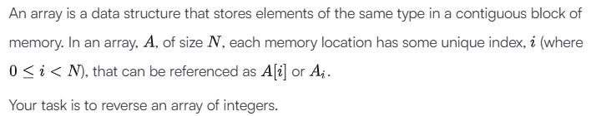
Ans.
import math

import random

def reverseArray(a):
c=""
for i in a[::-1]:
c+=str(i)+" "
print(c)

if __name__ == '__main__':

arr_count = int(input().strip())

arr = list(map(int, input().rstrip().split()))

res = reverseArray(arr)

2.
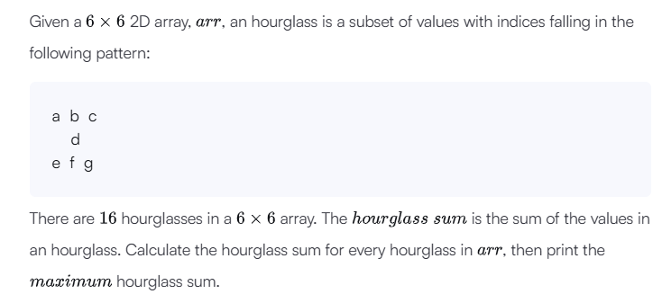
Ans.
import math
import os
import random
import re
import sys

def hourglassSum(arr):
max_sum = float('-inf')

for i in range(4):
for j in range(4):
current_sum = (
arr[i][j] + arr[i][j+1] + arr[i][j+2] +
arr[i+1][j+1] +
arr[i+2][j] + arr[i+2][j+1] + arr[i+2][j+2]
)
max_sum = max(max_sum, current_sum)

return max_sum

if __name__ == '__main__':
fptr = open(os.environ['OUTPUT_PATH'], 'w')

arr = []

for _ in range(6):
arr.append(list(map(int, input().rstrip().split())))

result = hourglassSum(arr)

fptr.write(str(result) + '\n')

fptr.close()
3.
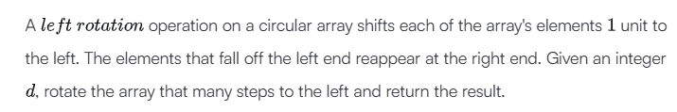
Ans.
import math
import os
import random
import re
import sys

def rotateLeft(d, arr):
d = d % len(arr)
return arr[d:] + arr[:d]

if __name__ == '__main__':
fptr = open(os.environ['OUTPUT_PATH'], 'w')

first_multiple_input = input().rstrip().split()

n = int(first_multiple_input[0])

d = int(first_multiple_input[1])

arr = list(map(int, input().rstrip().split()))

result = rotateLeft(d, arr)

fptr.write(' '.join(map(str, result)))
fptr.write('\n')

fptr.close()
4.
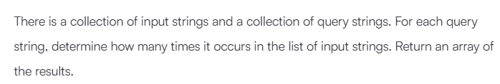

Ans.
import math
import os
import random
import re
import sys

def matchingStrings(stringList, queries):
frequency_map = {}

for s in stringList:
frequency_map[s] = frequency_map.get(s, 0) + 1

results = []
for q in queries:
results.append(frequency_map.get(q, 0))

return results
if __name__ == '__main__':
fptr = open(os.environ['OUTPUT_PATH'], 'w')

stringList_count = int(input().strip())

stringList = []

for _ in range(stringList_count):
stringList_item = input()
stringList.append(stringList_item)

queries_count = int(input().strip())

queries = []

for _ in range(queries_count):
queries_item = input()
queries.append(queries_item)

res = matchingStrings(stringList, queries)

fptr.write('\n'.join(map(str, res)))
fptr.write('\n')

fptr.close()

